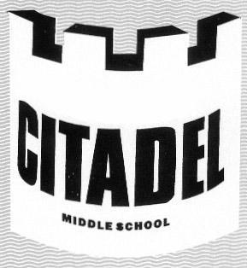
Citadel Middle School

Performing Arts Registration

Dear students and parents/guardians:

You are being given the option to choose from a selection of performing arts courses for the 2014-15 school year. Read the descriptions carefully, and choose the course you are most interested in taking.

Your choices are:

BEGINNER BAND: for students who want to learn to play a concert band instrument (e.g., flute, clarinet, saxophone, percussion, trumpet, violin, etc.). Students are required to rent or purchase their instrument of choice and purchase a band music book (specific instructions will be given during the first week of September).

SENIOR BAND: for students who have already learned how to play a concert band instrument and who have a minimum of one year's experience with that instrument. Students are required to rent or purchase their instrument of choice and purchase a band music book (specific instructions will be given during the first week of September).

BEGINNER GUITAR: for students interested in learning how to play the acoustic guitar. Students are required to rent or purchase their own acoustic guitar. If, due to financial hardship, you are unable to rent or purchase a guitar, please contact Ms. Speight in the office and arrangements will be made.

ADVANCED GUITAR: for students who can already play notes and chords on the acoustic guitar. Students are required to rent or purchase their own acoustic guitar.

MUSIC: for students interested in exploring a variety of musical experiences which may include Djembe drumming, Orff instruments (xylophones), Stomp, Blue Man Group, junkyard bands, recorders, ukulele, and many others.

SING, DANCE, ACT: for students who are interested in musical theatre. Students will be required to participate in all elements: singing, dancing, and acting.

Once you have made your decision, fill in the form below and return it to the office by THURSDAY, JUNE 12th, 2014. PRINT CLEARLY!

Last Name: _________________________ First Name(s): ____________________________

In September 2014, which grade will you be in? ☐ Grade 6 ☐ Grade 7 ☐ Grade 8

Choose the course you most want to take during the 2014-15 school year. Choose ONE ONLY.

☐ Beginner Band | ☐ Beginner Guitar | ☐ Music
☐ Senior Band | ☐ Advanced Guitar | ☐ Sing, Dance, Act

If you chose Beginner or Senior Band, tell us which instrument you plan on playing:

_________________________ How many years of experience (Senior Band Only)? _______

Parent/Guardian signature:

I, ________________________________ hereby give my permission for my child to register for the above performing arts course for the 2014-15 school year.

_____________________________ ______________________
Parent/Guardian Signature Date

